Cubix the Cycling Database
Final Project
For
IST659 – Database Admin Concepts & Management
by
Quawan Smith
A report submitted in partial fulfillment of the requirements for IST659
Submitted to
Clark Thompson
On
May 4th

Quawan Smith
915 Clinton St APT 4D
Hoboken, New Jersey, 07030
315-200-8296
qdsmith@syr.edu

Clark Thompson
Syracuse University School of Information Studies
Syracuse, NY 13224

Dear Clark:

The contents of this report contain a comprehensive description of the database solution engineered to address my proposed problem. Enclosed in this report are details to the business problem identified and scope of the overall project. The project will level set on how some the cycling retails stores perform day-to-day operations currently. Documents for reference include any UIs used, a data dictionary, system catalog, data populated into an excel file, VB macro to generate inserts statements, conclusion, lessons learned, and an appendix.

The structure of the report consists of 10 parts. In the Planning (Section 1) portion of this report it gives an overview of how business is currently done. This section of the report also talks to some of the caveats to performing business operation without a data driven solution or only having a system that does not contribute to streamlining process or maximizing profit. In the Analysis (Section 2) portion of this report talks to the key operational features that will be supported using the data driven solution described in this report. Additionally this section will talk to the benefits for both the employees and customers. In the Design (Section 3) portion of the report a list of business rules will be detailed and the ERD will be provided as well. In the Implementation (Section 4) portion will detail the forms and reports that will be used to interact with the database. It will also contain views and queries. In the Support Requirements (section 5) portion it will discuss what plans should be in place for backup and recovery. It will also talk to the security concerns that come with running a data-driven business and how they should be addressed. In the Documentation (Section 6) portion of the report will contain the data dictionary and the system catalog. The data dictionary will contain an explanation of data attributes used to support this solution. The system catalog will contain a business language description of the different objects/tables. The Conclusion (Section 7) will discuss implementation requirements to get the best use out of the database. Lesson Learned (Section 8) will provide insight that can be used to expand on this solution and opportunities for future database solutions in the cycling industry. Sources (Section 9) will provide all resources used to put this report together. Lastly the Appendix (Section 10) will contain reference information to keys items within the report.

Please inform me if any concerns or question. I can be reachable at 315-200-8296
Sincerely,

Quawan Smith

Table of Contents

Executive Summary 1
1 Planning 3
1.1 Description of the Business 3
1.2 Business Problem 3
1.3 Decisions not made 4
1.4 Project Scope 4
1.5 Assumptions and Constraints 6
2 Analysis 6
2.1 Methodology 6
2.2 Processes Supported 6
2.3 Key Personnel 7
2.4 How Work Changes 7
2.5 Benefits 7
2.6 Management Problems 8
3 Design 8
3.1 Business Rules 8
3.2 Data Model 10
4 Implementation 11
4.1 Input Forms 11
4.2 Reports 16
4.3 Additional Database Objects 21
5 Support Requirements 23
6 Documentation 24
7 Conclusion 30
8 Lessons Learned 30
9 Sources 31
10 Appendix 32

List of Figures

Form 1 – Employees By Location 11
Form 2 – Employee 12
Form 3 – Location Service Price 13
Form 4 – Bike Inventory 14
Form 5 - Location 15
Form 6 – Location Bike Service 17
Form 7 – Events by Location 18
Form 8 – Reference Location 19
Report 1 – Employee Work Report 20
Report 2 – Event Customers 21

Executive Summary
Visiting a bike shop is a very personal experience. Often cyclists will gravitate to one or 2 bike shops to fulfill all their cycling needs. Most of the business in some shops is ran by usually just a verbal agreement and perhaps a physical note reminding the bike mechanic what work needs to be done to a particular bike. It is common for bike shops to use computers to track warehouse inventory. That is usually a 3rd party system that is not very customized to the unique needs of each bike shop. It can only answer the question “is there any additional bikes left in size x”. Much information can be gained from having a tracking system that tracks the key actions of the business. Additionally a key gap is bike shops that have different owners do not have a way to communicate or create relationships that could enhance customer experience and drive up profits.
When new customers or cyclist come to a bike shop they will want the right size and desire a particular color scheme. New cyclists may not be certain if they want to commit to a bike at first. So usually that results in the customer going to other bike shops hoping they have the bike just right for him or her. But there is little value going to a bike shop that does not even sell the brand desired. But there is no way for another bike shop to know what inventory is available outside of its own inventory system. And once a customer have committed to a bike it may need tune-ups throughout the year. Currently when a bike has been serviced the customer gets a phone call. He or She has no way to know if work on his or her bike has been started. Bikes shops also offer classes and events as well. Usually events bring in business as bike needs to be tuned for long rides. But if events and services are not tracked it is difficult to quantify this increase in volume.

An integrated data solution that tracks key operations will streamline processes and also bike store owners can get the most value from customer interactions. The data solution Cubix is intended to be a solution that bike shops can customize to their needs. Although outside the scope of this report it will allow customers to see and check the status of their bike online. The online front end will give the user the ability to see an aggregate view of all the bikes from the different bike shops that choose to use this solution.
Cubrix allows collecting data on events, customers, and employee activity by location. It also will allow for better decisions to be made. Reports that can be generated to show which genre of bike sells the most or which bikes are serviced the most. The reports will also allow the store manager to see which bike mechanics work on the most bikes. The solutions also have the flexibility to allow employees to change a locations if they are hired somewhere else. Lastly this solution will provide the ability track referrals from one bike shop to another.
The technology driving the database environment will be MS SQL for the creation of all the database objects and Access will be used to update and interact with the database objects. All reports will be generated in Access. The project methodology that will be utilized is the SDLC. Key personnel have been identified to be all the employees and customers of each bike shop.
The Design includes the data model, business rules, data dictionary and system catalog. The data model will detail the relationship with the database objects. The business rules will list key functions of the bike shop operations and how they are implemented in Cubix. The data dictionary will give details of the fields of the tables. The system catalog will provide details of the tables, forms, and reports.
The conclusion will give some insight on how the solution can be extrapolated out to other industries. It will talk to the next phase of the solution that was out of scope for this project due to limited time. The lessons learned section will relate the key concepts learned throughout this class and how they were applied in Cubix. The sources included will be in APA format and contain any outside reference material used to engineer the data solution. And lastly the appendices will contain additional reference items as needed to extend the explanation of the solution components.

Planning

Description of the Business
The business I am targeting is the cycling sales industry. Bikes are a great way to stay in top shape. And it is a sport that can be challenging to athletic professionals as well as these looking for a fun activity to get back into shape or build endurance. Small bike shops often do not concern themselves with how technology could help promote business or streamline processes. Some bike shops are so small they only consist of one or 2 Bike Mechanics and a Sales Representative. Often small bike shops do not have their full inventory online or stored in a database. Most of the business is done in person. Some shops have databases to their warehouses to determine if a bike is in stock but no sophisticated system that tracks individual parts or even a comprehensive view of past purchases. There are many online companies like Amazon that does sale cycling gear and bikes as well. But a major part of purchasing a bike is the sizing and when it comes to bikes it is not an exact science and every bike brand uses different sizing standards. So ordering a bike online can be risky if one did not test that exact make and model first. Going to a bike shop and going for a test ride is the best way to determine if it is the right fit. Some bikes shops offer more than just the selling of different types of bikes and bike gear. Often bike shops are great rest stops for long rides. And bike shops may even offer classes on bike maintenance as well.

Business Problem
Part of why a large percentage of small bike shops may not have a sophisticated database system is that the cost of having such a system for small bike shops may be far outside the budget. But several issues come from the absence of a database system that can digitally track operations.

- When a bike is brought in for a tune up is there a way to track its completion status or if it is behind schedule? Currently you have to call during business hours to check this.

- If you see or find a bike that you like but that bike shop does not have the size on site they can always just check their warehouse to see if they have the size. But what if their particular warehouse does not have the size either. Maybe one of the 6 bikes shops in the area may have it? But you will have to go through this process 6 more times.

- What if you find a bike you like but do not like the color? Or would like certain parts customized. If there were preset colors or patterns the costumer would have more choices per bike.

- If the bike shop wanted a view of all their clients in the past year and all the services rendered for a particular customer. Did that customer come to any classes? What percentage of sales comes from repeat customers? What category of bikes is producing the most successful sales? It is quite difficult to answer these questions without a database system.

- Additional questions to give thought to: Is there a correlation to major cycling events and customers demand for bike services? How can this demand be better meant in a way that can generate additional revenue?

Decisions not made
The business decisions that cannot be resolved without a database oriented solution includes
- If a customer goes to a bike shop location and can find a particular bike. The Sale Representative can only inform the customer if the bike is available at the current store. The Sale Representative cannot inform that customer if surrounding locations have the bike he or she is looking for.
- Bike Mechanics that comes in for a shift do not know without asking someone who is working on what bike.
- The manager has no way of determining relationships between events and customer volume.
- The manager does not know who of his or her mechanics take on the most work. The number of bikes worked on is not an accurate representation of this. If a mechanic worked on 10 bikes but only did pedal installations that mechanic did less work than a mechanic that worked on 5 bikes and had to perform full tune-ups to each bike.
- If a bike shop want to recommend a customer to another store there is no incentive to do so. But if there was a way to track a referral fee if the customer does business at the other store that would mutually help both bike shops.

Project Scope
I am proposing a customized open source database system that targets small bike shops that could vastly benefit from digitalizing operations. This database will actually connect different bike shops in the area if they chose to share their inventory. Additionally it will allow bike shops to isolate portions of the business operations they do not want share like sale history. The database itself will support a variety of functions like sales reporting, event tracking, importing warehouse inventory, inventory sharing, and service & inventory tracking. Additional users will have the ability to log on to their account and track their own history. And all the bike shops using the online database would appear in the users’ account. Outside the scope of the project would be the development of a frontend online interface to interact with the database. Security will be addressed but it will not be the focal point of this solution.

Each bike shop that would utilized this solution will logically have a separate database environment in which only that particular store will have access to by default. There will be a master table to track all the stores registered to use open source solution. Each bike shop will have its own group of database objects, storage, etc. But the value of this solution comes from the ability to share information that would be mutually beneficial to all bike shops that is registered to use this open source database solution. If a bike shop chooses to share their inventory with other shops in the area using this solution then a customer would know if a particular model and size is available in their area. The incentive of one bike shop directing a customer to another bike shop would be the ability for them to charge a referral fee to all the bike shops registered to use the solution. Referral fees would have the ability be tracked and adjusted. The referral fee would only be applied if that particular bike model and size is purchased at the bike shop being referred.

The focus of the project will be on creating a database that has the ability to offer inventory, customer, and service tracking. Additionally it will encompass the tracking of classes or other special events customers may be interested in. Also a table will be added that stores predefined color schemes that can be applied to all bikes within a particular category (road, hybrid, mountain, etc). Sharing of data will be driven by various views. Predefined views will be created. There will be a field to track whether these views will be open to everyone using the open source solution. The actual interpretation of this column would be an application function and the technical details of this would be outside the scope this project.

Finally several predefined reports that illustrates customer spending history and any classes that customer may have participated in. These reports will answer the question of “is there a correlation to major cycling events and customer demand for bike services? How can this demand be better meant in a way that can generate additional revenue?”

Assumptions and Constraints
The ideal database environment to use to architect this open source solution would be MySQL since it is an open source relational database. But utilizing MS SQL or any other relational database will not change the logical design. In order to be a fully usable solution careful design of the web based front end will have to be considered. I will be basing my design under the assumption that there is a separate development initiative to create a web application and/or mobile application that will use my database solution.
Since my solution is open source the online community will contribute to maintenance concerns like backup and recovery. I wanted to design a solution that would also not require bike shops to hire any in-house IT support. So using my solution is no cost to register. Storage costs will be evaluated as the bike shop database grows. Data will be stored in the cloud.

Analysis

Methodology
The SDLC will be utilized to implement this solution. A special emphasis will be on user feedback and understanding the business of how bike shops operate. In the Planning phrase an understanding of how current operations are done will be evaluated. Multiple bike shops will be sampled. Additionally cyclist will be interviewed to understand what would make their shopping and overall interaction with bike shops more streamlined. A conceptual design will be created at this stage. The Analysis phase will focus on the mapping requirements out and matching them with the appropriate entities and relevant attributes. A significant amount of time will be spent on evaluating the logical model to confirm it incorporates all the functions the bikes shops will need to enhance their operations and cyclists’ shopping experience. The physical design will encompass the tables, tablespaces schemas, indexes, indexespaces etc. Implementation phase will include any reports specifically engineered to give information that will assist in the business decision making process. Training will be administrated via a help page on the website. There will also be a forum page on the website where questions can be posted. (Once again the actual design of the website will not be detailed in this project)

Processes Supported
The customized database environment will support several major operations of the bike shops.
- Customer information along with purchase history and classes attended will now be stored.
- The bike shop will have the ability to record major events. This will allow reports to be generated to determine if there are increase demands surrounding the dates of these events.
- Service on bikes brought in can now be tracked. The mechanic can update the database on when the bike repairs are in progress and when they are completed.
- The database will support the ability to store preset design patterns that can be applied to certain categories of bikes.
- Bikes shops will be able to tracked what their referral fee is and charge it when they direct a customer to a different bike shop and the customer decide to purchase the bike or product

Key Personnel
Any employees and customers of the bike shop would be the key stakeholders of this project. The sale representatives will be updating the database with new customers and events. The bike mechanics will be updating the status of the various bikes being worked on. If that shop supports repainting frames then the mechanics will be able to use the database to determine if a particular preset color scheme is available for a particular bike. This information will also be used by the sale representatives to inform customers if their desired color can be applied to a particular bike. Customers will have the ability to track the latest status of the service they will be purchasing. The owner of the bike shop would also be identified as a key stakeholder as he or she will determine how the business will change after having a deeper level of tracking and reporting of the critical business operations.

How Work Changes
The bike mechanic will now track his or her work via the new database system. He or she will have the ability to determine how many bikes were worked on given a particular time frame. The sale representative has the ability to instantly determine what products are in stock within multiple stores in the area. The mechanic will have to have a computer or a tablet close to his or her workstation to make sure entering data in the database is not a burden. The store owners will have to determine formal ways to review monthly metrics with employees. As it stands currently there are bike shops that use Excel to track costumers. Others only use computers to print receipts and nothing beyond that.

Benefits
At the end of every year all the bike shop employees can look back and see what bikes were the most popular. This can translate into the bike shop’s owner stocking up on these bikes for the next fiscal year. Also the employee can suggest an onsite classes based on the most popular type of service I.E. tune-ups, gear adjustments, and customize fittings. Since the database tracks contact information all these former customers can be engaged via email. If a particular event drew more demand during a particular time frame then perhaps it was be worth extending store hours during that time. Ultimately the information offered will lead to better a customer engagement model and have products in stock that cyclist have a high probability of purchasing.

Management Problems
Naturally there will be a high learning curve for those shops that do not currently leverage heavily a computer environment that requires employees to constantly interface with it. Basic computer concepts would be required to successfully use this solution. Employees will have to take the time to determine how to utilize all the functions before interacting with a customer to confirm that the use of the database system is not slowing down productivity. Some bike shops may be reluctant to offer their inventory to be viewed by other bike shop for fear of losing customers. But the suggested referral fee can offer another stream of revenue.

Design
The design for this project will follow all relevant best practices. Below are the business rules that were the foundation for this project. From the business rules below an ERD was engineered to support core functionalities. The database objects created from the data model below is where all the data will be stored for the different bike shops. There are 17 tables to support the functionality of this database environment. The ERD has been engineered to 3rd normal from. This solution was built with the consideration that it will be expanded therefore the need for scalability was assumed. The data model is not specific to a particular data base system. It can easily be reengineered to another database system. For this project data will be entered via forms in Microsoft Access. Once data is updated in MS Access the MS SQL database will be synchronous updated as well. For future considerations data can come from a website, remote RF device, or on site application.

Business Rules
 | Business Rule | Implementation
1 | Each Location must supply at a minimal of the store name, address, zipcode, and city | Within the entity Location these fields cannot be null.
2 | Each Location will have their own bikes in stock | BikeInventory entity there is a one to many relationship from Location to BikeInventory
3 | Bikes in the shop can used or old must have an inventory number | BikeInventory entity uses the bikeInventoryID Number as the primary key.
4 | All customers that come in are asked what category of Bikes they are looking for. The most popular categories are Hybrids, Mountain Bikes, and Road bikes | The BikeType entity will have all 3 categories populated
5 | The bike shops buy used bikes and advertise the bike as used. | The BikeInventory Entity relates to the BikeCondition. The relationship is many bikes can either be new or used.  This table will always only have 3 rows new, used, or external. A constraint will be implemented to enforce this. BikeInventory will have attribute to the store the selling price of the used bike
6 | Bike Shops can change bike prices of any bike new or old. | Current Prices can be updated in the BikeInventory Table.
7 | Bike shops offer a variety of different services: including tune-ups, tire repairs, Derailleur adjustments, etc. Each service has different prices that can be subject to change. | The Service entity has a many to many relationships with the Location entity. The associative entity LocationService store the many-to-many relationship and have an attribute for price
8 | When a customer brings in a bike to be serviced it is considered to be the category of “external” | The bike that is brought in is stored in the BikeInventory table and it will point to “external” in the BikeType table. This bike then can be associated with the services needed. The data model supports the nature of a bike needing multiple services and multiple services can be applied to many bikes. BikeInventoryService is the Bridge table
9 | A bike brought in may not have a serial number that can be deciphered. An inventory number will automatically be assigned in this case. | bikeSerialNum is an optional field since there are cases where the serial number is impossible to read
10 | One bike shop can refer a customer to another bike shop if the first bike shop does not have the bike in stock the customer needs | All references are stored in the Reference table. The customer involved and the bike being referred will be stored in the Reference table as well. referLocationID identifies the bike shop doing the referring and referToLocation is the bike shop being referred
11. | Employees are assigned to particular roles for a store. IE Bike Mechanic, sales associated, etc. | There is an EmployeeRole table that will have one role that many employees can have.
12 | Bike Mechanics are assigned to bikes to preform particular services | In the BikeInventoryService an Employee (empID) is assigned to an assignment or task.
13 | Each location can offer different or the same services but the price is determined by the location | The LocationService table allows each location to set a price independently.
14 | Both the customer and employees will need to know what services have been completed | ServiceStatus has 4 valid statuses:  statusName = 'NOT YET STARTED'  statusName = 'IN PROGRESS'  statusName = 'COMPLETED: READY FOR PICK UP'  statusName = 'COMPLETED: RETURNED TO CUSTOMER'
15 | Events and attendees can be tracked | Events can be tracked via the Event table. The EventCustomer table is to track the customers that have attended the associated event.

Data Model
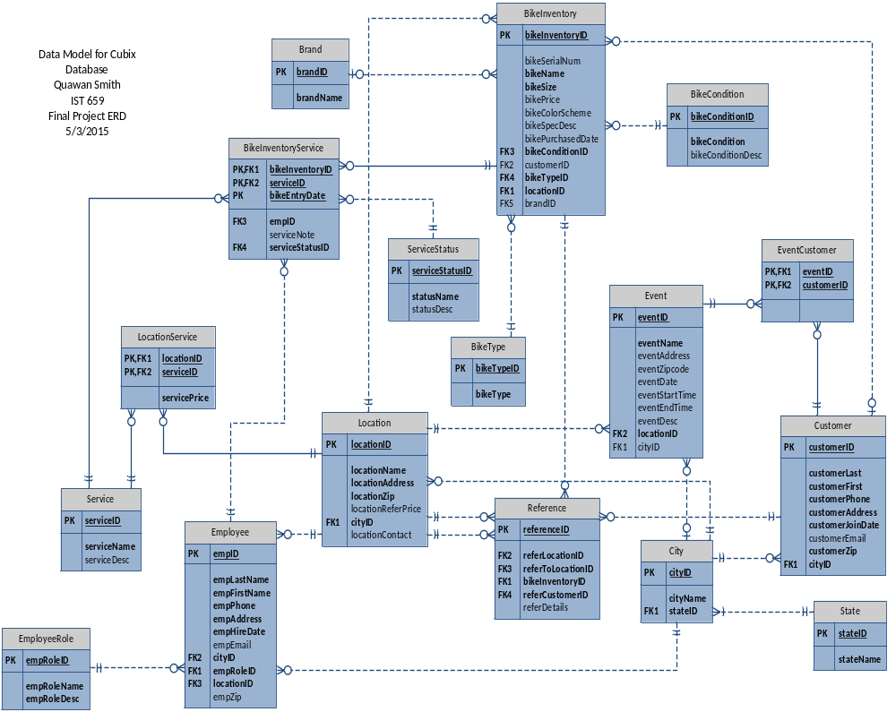

Implementation
Below are the forms and reports that the user will interact with to view, update, and delete data as needed. All relationships in MS SQL will be replicated in MS Access for consistency and to validate integrity.

Input Forms
Form 1 Employees By Location - This form details all the employees for each location. Every location record will show the list of employees already assigned to that location.
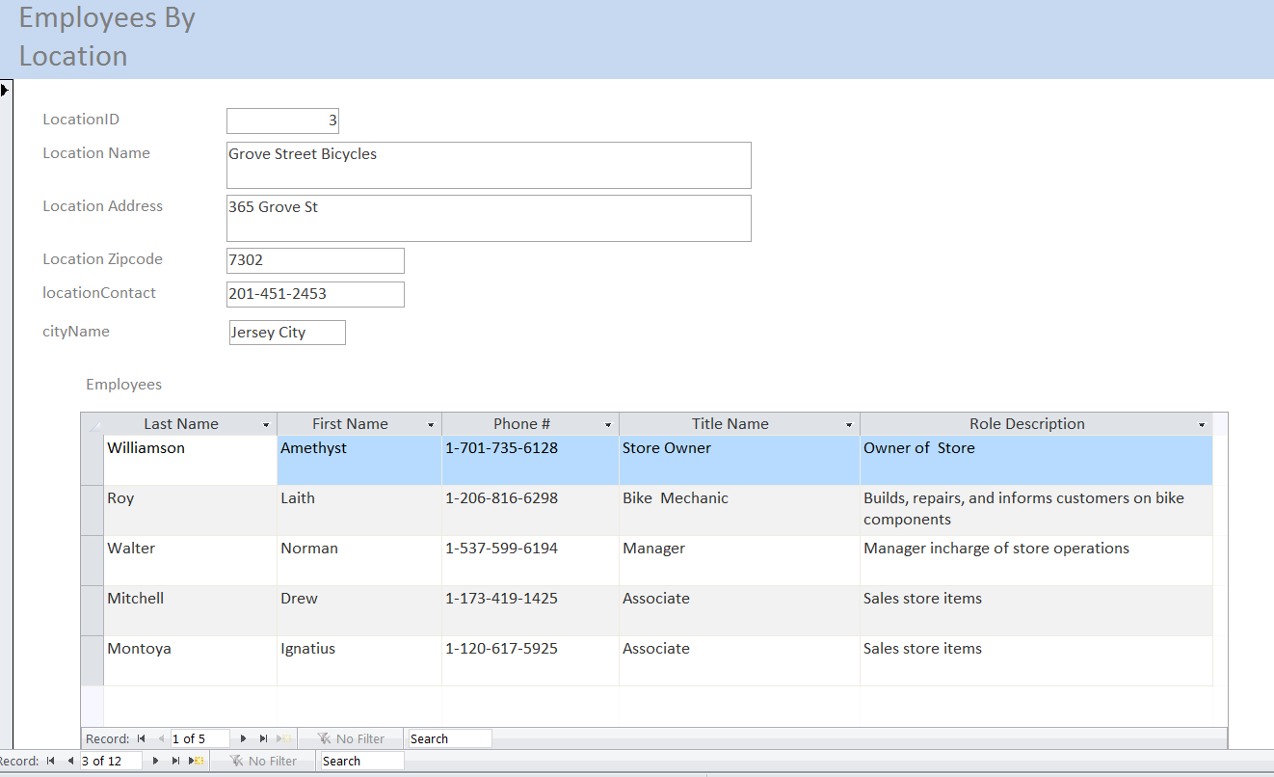

Form 2 Employee - The form below allows employees to be added, updated, or deleted where needed. Combo boxes have been put in place to allow the new employee to be assigned to a city, role, and location. Once the employee is assigned a location the Empolyees by Location form is updated with the new employee.
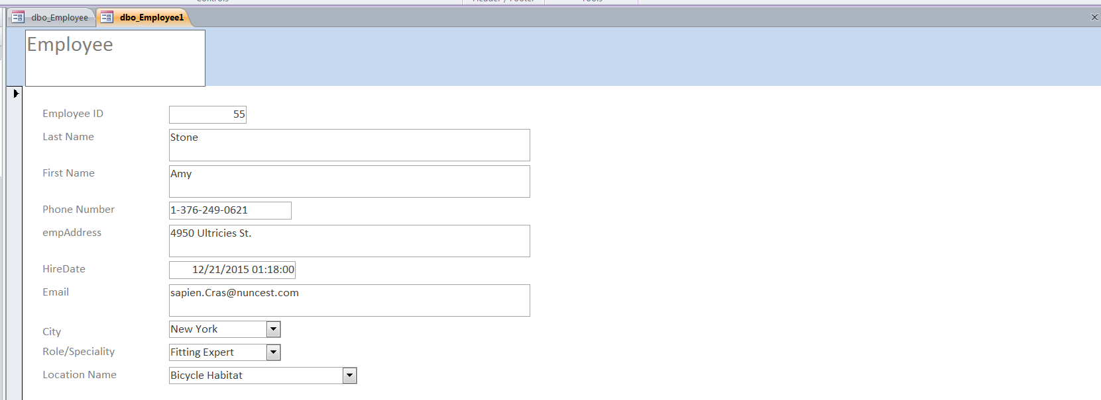

Form 3 Location Service Price - The following form list the services each location offers. It also list the prices since each location can have difference prices.
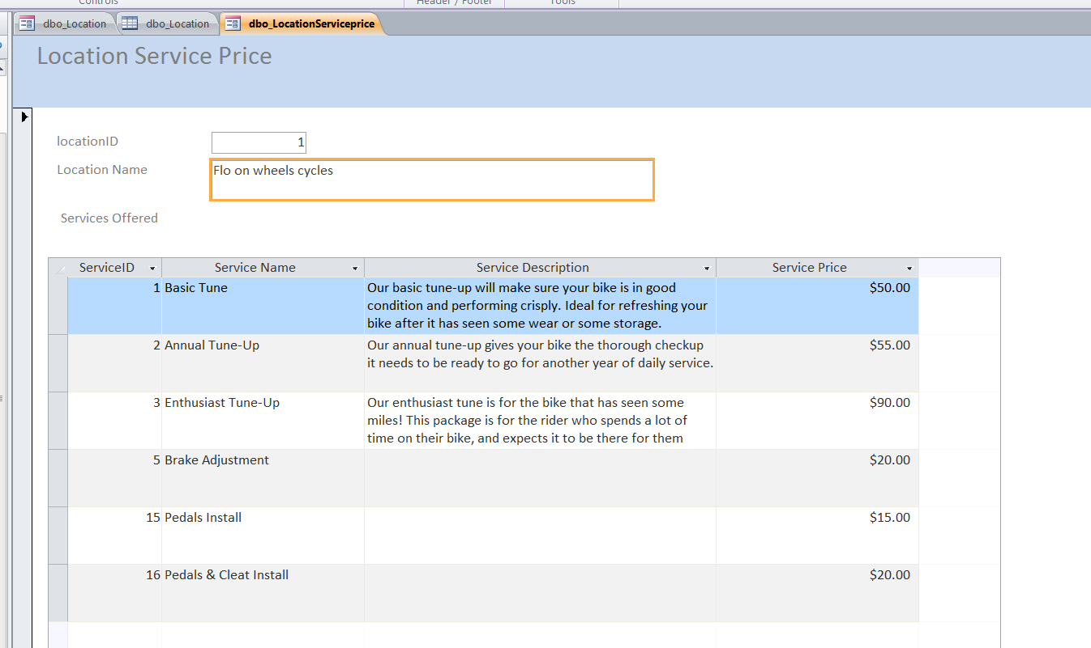

Form 4 Bike Inventory - Bikes can be added and assigned to a store. Customer ID is only populated if the bike is listed as external. Which implies it was brought in from somewhere or it was already purchased. A new bike in this form can be assigned to a location, brand, type. A bike listed as external can be assigned to an customer.
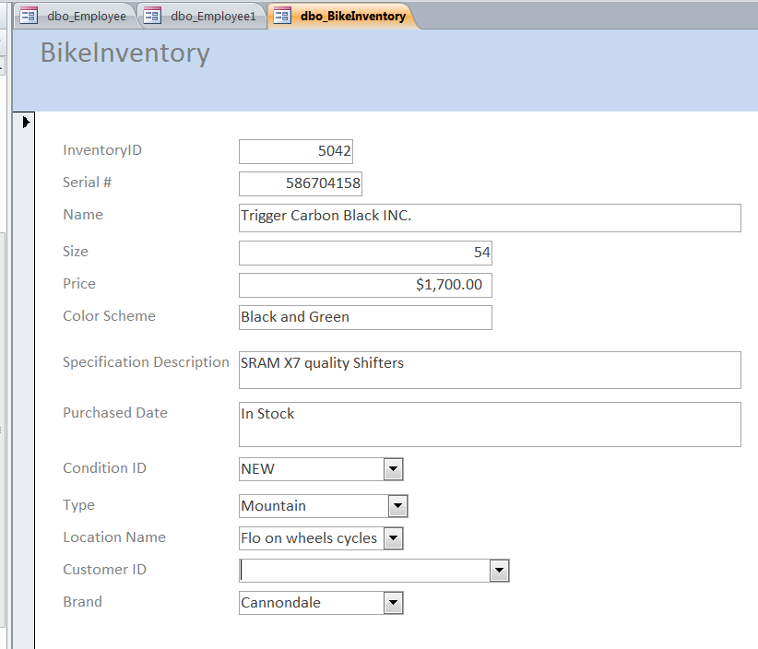

Form 5 Location - The form below lists all bikes per location. Now customers can be referred to another bike shop if a pacticular bike shop do not have the specific bike needed in inventory. Inventory can be checked in advance by location. The sale representative can also give the address of the other location using this form. Also note the color schemes are listed as well. If a color scheme is not available in one location for a particular bike it may be in stock at another location.
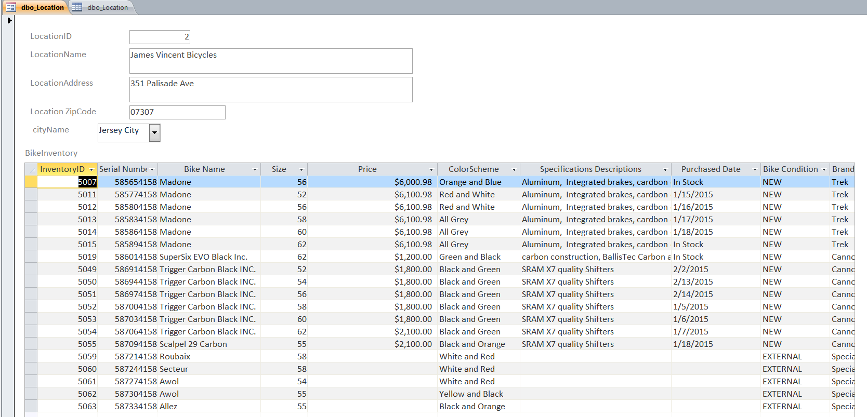

The form below is just part 2 to the form 5 above.

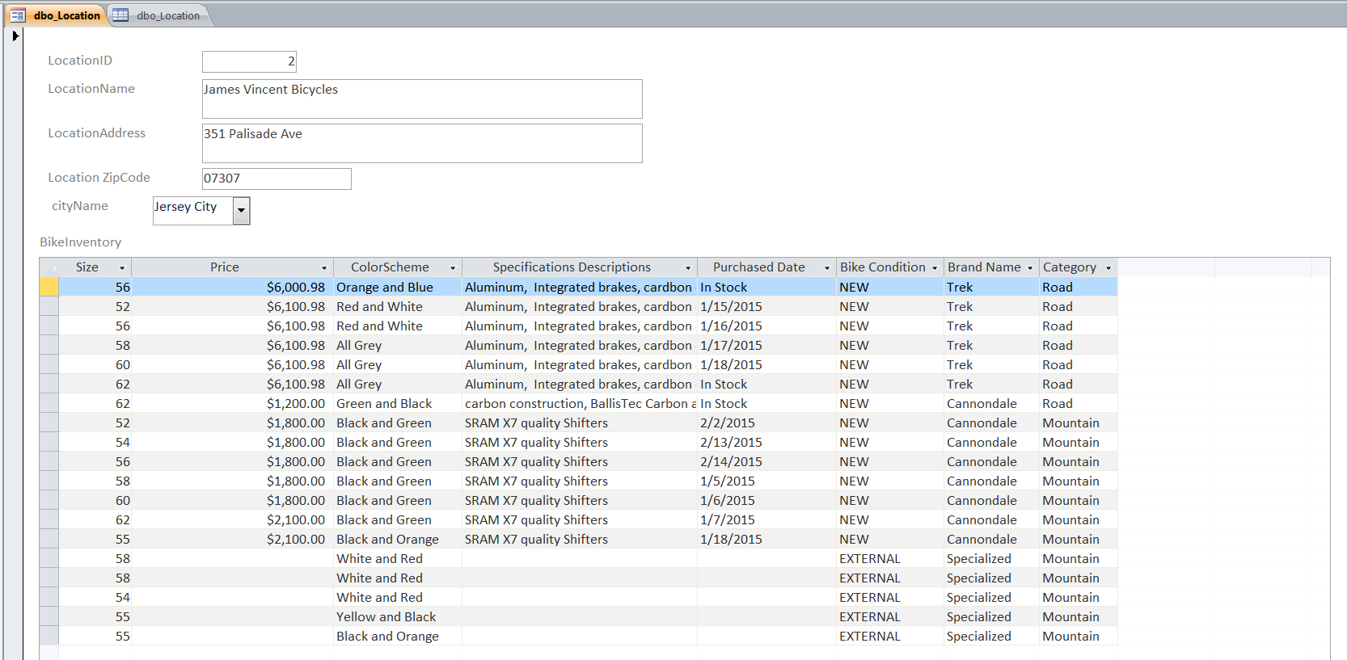

Form 6 Location Bike Service - The form below lists by location. The bike mechanics now know what bikes have already been completed and returned to customer. No need to call the customer since an automated email will be sent out. The bike mechanic also know what type was work was done on a particular bike.
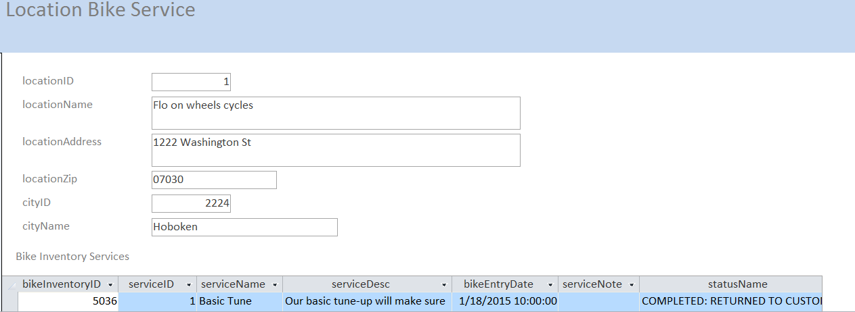
The form below is just part 2 to the form above.
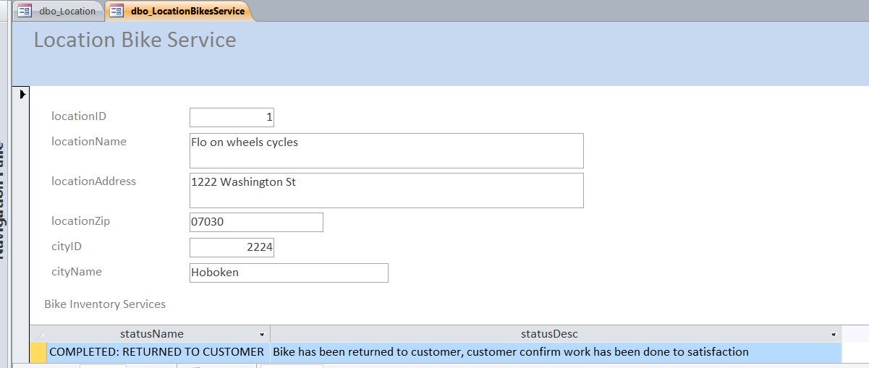

Form 7 Events by Location - The form below list the events ongoing by location. A customer can view this and can attend the event. Events utimately help drive up revenue since they require a well tuned bike for long rides.
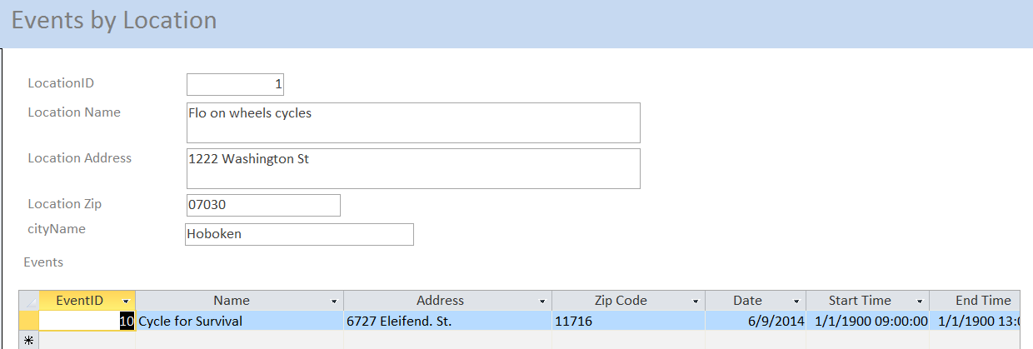
The form below is just part 2 to the form above.
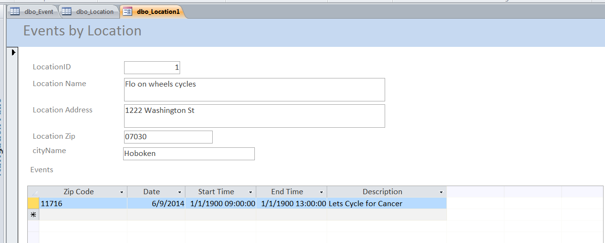

Form 8 Reference Location - The intend of the form below is to give a view what bike shops are referring other locations. Each bike shop doing the referring can charge a fee if the customer goes to the bikes shop referred and buys the bike. Now there is incentive for a location to refer another location. This also serves as another avenue of quantifiable revenue.
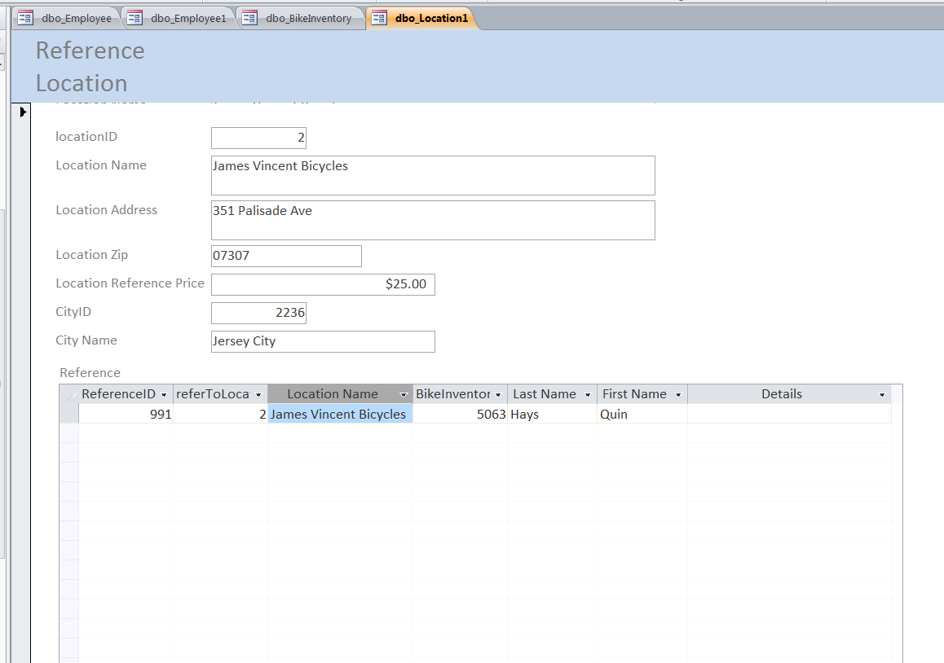

Reports

Report 1 Employee Work Report - This report allows all the employees in a particular location to know what work was done and what work was in process. Now the Bike Mechanic knows that bikes they were assigned to as well. If the Status Name column is “IN PROGRESS” this implies that the service under Service name column still needs to be completed. This report additionally allows the manager of each store to know who is completing the most services on which bikes as well.
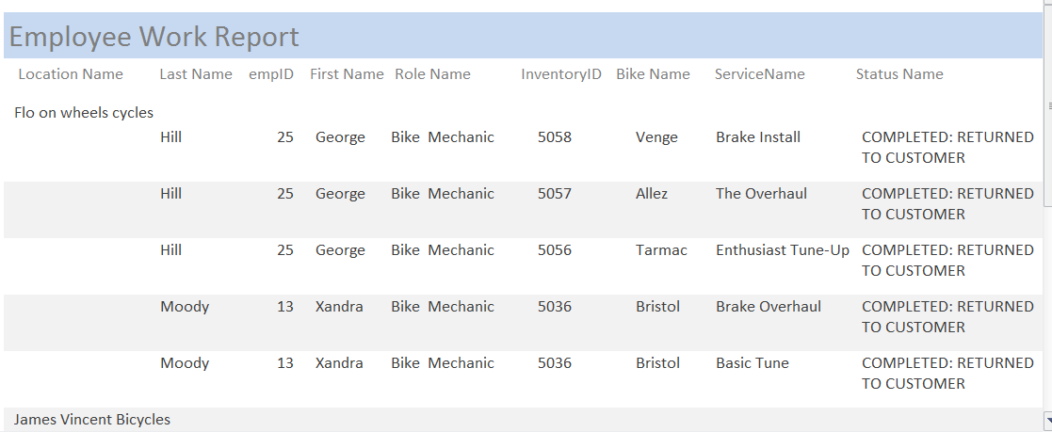

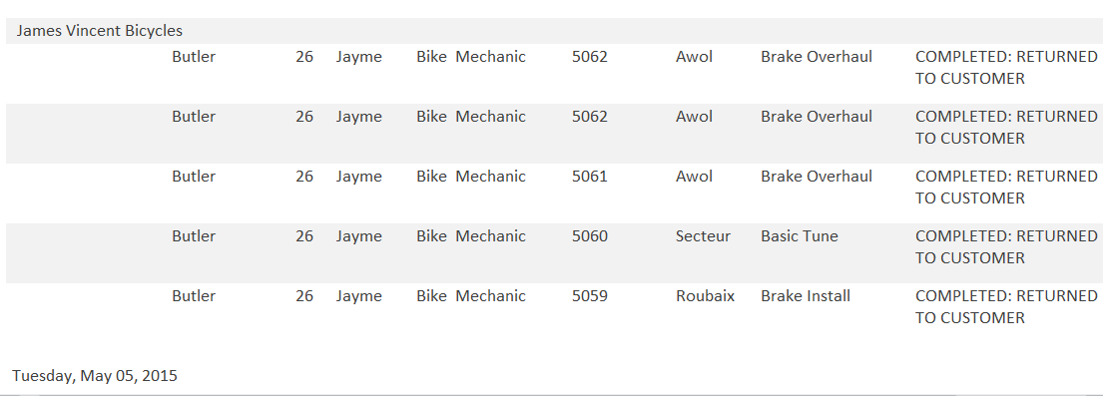

Report 2 Event Customers- The intend of this report is to show the customer activity during the month a event occurred. This is to determine if events have a correlation to the amount of work received. For example if a bike shop is hosting a long bike ride it is reasonable to see a spike in the number of tune-ups prior to the date of the event. This is powerful information that a store owner can use to determine if additional help may be needed to satify demand in a puntual manner.
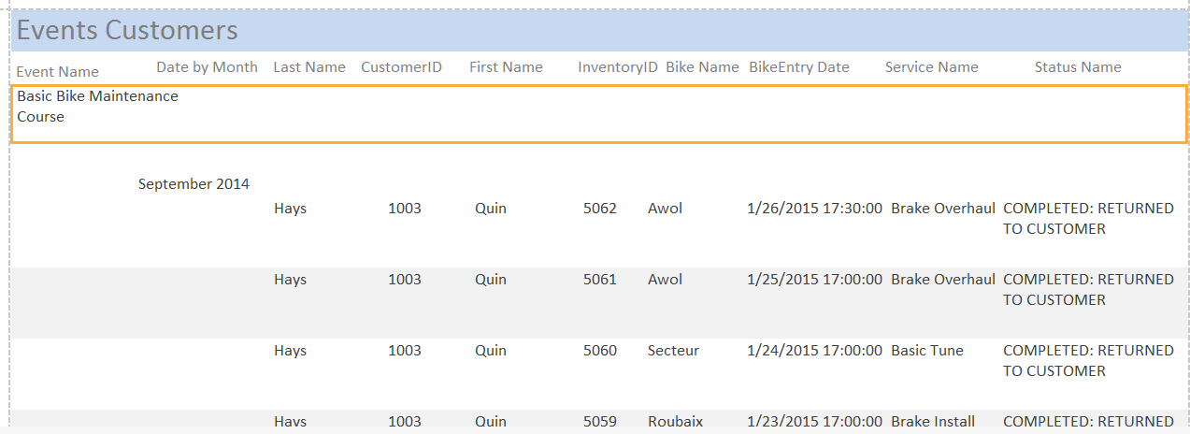

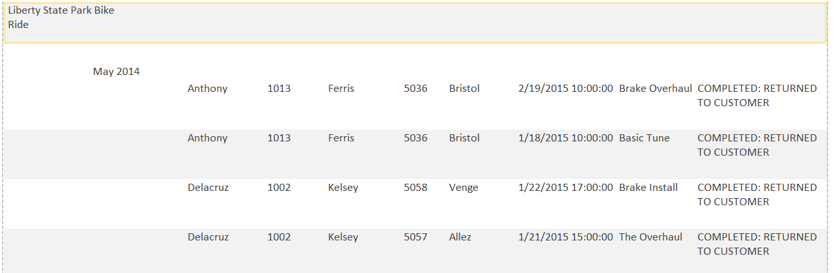

Additional Database Objects
The system table query returns all the constraints created in the Cubix database for MS SQL in table name order. For check constraints it also gives the definitions. This query is for a database administrator that would be able to interpret the data returned in this query.
SELECT sys.tables.object_id,
sys.tables.name 'Table Name',
sys.check_constraints.name 'Object Name',
sys.check_constraints.type_desc 'Object Type',
sys.check_constraints.definition 'Definition'
From sys.tables
RIGHT JOIN sys.check_constraints ON sys.tables.object_id=sys.check_constraints.parent_object_id
UNION ALL
SElECT sys.tables.object_id,
sys.tables.name 'Table Name',
sys.key_constraints.name 'Object Name',
sys.key_constraints.type_desc 'Object Type',
'N/A'
From sys.tables
Right JOIN sys.key_constraints ON sys.tables.object_id=sys.key_constraints.parent_object_id
UNION ALL
SElECT sys.tables.object_id,
sys.tables.name 'Table Name',
sys.foreign_keys.name 'Object Name',
sys.foreign_keys.type_desc 'Object Type',
'N/A'
From sys.tables
Right JOIN sys.foreign_keys ON sys.tables.object_id=sys.foreign_keys.parent_object_id
ORDER BY sys.tables.name ASC;
The query below returns all the work done on bikes for all locations. The data returned in this query will be used in the next phase of this project which is the implementation of a web front end interface.
Select employee.empLastName as 'Last Name',
employee.empFirstName as 'First Name',
service.serviceName as 'Service Completed',
bikeInventoryService.bikeEntryDate as 'Entry Date',
serviceStatus.statusName as 'Status'
From BikeInventoryService
JOIN employee on BikeInventoryService.empID = employee.empID
JOIN service on BikeInventoryService.serviceID = service.serviceID
JOIN serviceStatus on serviceStatus.serviceStatusID = BikeInventoryService.serviceStatusID
order by employee.empLastName

The query below returns all services offered by every location. The query orders each service by the lowest price per service. The data returned in this query will be used in the next phase of this project which is the implementation of a web front end interface.
Select locationService.servicePrice 'Price',
service.serviceName,
location.locationName
From locationService
JOIN Service on service.serviceID = locationService.serviceID
JOIN Location on location.locationID = locationService.locationID
Order by service.serviceName, locationService.servicePrice
The query below returns the total revenue of all the locations that have sold bikes in 2015. The query uses the fact that the bikePurchaseDate column in the bikeInventory table has a valid date if a bike was purchased. The query is grouped by location and will return records in order of greatest to least Total Revenue. If owner owns multiple locations he or she can see which location has sold the most bikes. The query just have to be altered to have the where clause narrow down the result set to include only certain locations. The data returned in this query will be used in the next phase of this project which is the implementation of a web front end interface.
Select bikeinventory.locationID 'Location ID',
Location.locationName 'Location Name',
sum(bikeInventory.bikePrice) 'Total Revenue' From Bikeinventory
JOIN location On location.locationID = bikeinventory.locationID
Where isdate(bikeinventory.bikePurchasedDate) = 1
Group by bikeinventory.locationid, Location.locationName
Order By sum(bikeinventory.bikePrice) Desc

Support Requirements
The Cubix database system will have data that runs the operations of multiple bike shops across different regions. Backups will be done nightly. In additional all data is written to a backup location synchronously with the production databases. If production was to have an outage the Disaster Recovery environment would automatically activate and this will be transparent to the user. Once the appropriate alerts are sent out the database support team can remediate the issue and switch back over to production. A replication product will be used to validate that production and the Disaster Recovery environment remain in sync.
Backups for the employee and bikeInventory tables and related tables that they are dependent on are kept permanently. Other tables are archived and over written after a 10 year period. If an employee leaves a bike shop and returns 20 years later his or her record should remain in the database.
All activity is logged to a log files and can be recreated for any reason. There is no sensitive personal data kept in Cubix like SSN or Credit card information. A table for the Customer payment information was not in scope. A separate system will be used to store this information.
All databases will be encrypted for all transmissions. Certain fields in later releases will be controlled by the location owner. The location owner will be able to determine whether he or she would like attributes like prices known to everyone.

Documentation

Data Dictionary
Below is a data dictionary for the BikeInventory and Location table. The following attributes are included in the tables below: Name, Description, Type/Size, Format, Domain, Default Derived, Key and Reference Tables.

Table Name: BikeInventory

Table Description: The BikeInventory contains columns that will effectively describe key characteristics of a bike. It includes characteristics customers will need to make a decision on what bike to purchase.

Name | Description | Type/Size | Format | Req’d | Domain | Default/Derived | Key | Ref. Table
bikeInventoryID | Bike Inventory | integer |  | Y |  |  | PK
bikeSerialNum | Bike Serial Number | integer |  | N
bikeName | Bike Name | varchar(100) |  | Y
bikeSize | Bike Size (In Centimeters) | decimal(10, 2) |  | Y
bikePrice | Bike Price | decimal(10, 2) | $9,999.99 | N
bikeColorScheme | Color Combinations of Frame | varchar(50) |  | N
bikeSpecDesc | Bike Specifications | varchar(500) |  | N
bikePurchasedDate | Bike Purchased Date | varchar(100) |  | N
bikeConditionID | Bike Condition ID | integer |  | Y |  |  | FK | BikeCondition
bikeTypeID | Bike TypeID | integer |  | Y |  |  | FK | BikeType
locationID | Location ID | integer |  | Y |  |  | FK | Location
customerID | Customer ID | integer |  | N |  |  | FK | Customer
brandID | BrandID | integer |  | N |  |  | FK | BrandID

Table Name: Location

Table Description: Location contains attributes that effectively describes all the store locations including a contact phone number to reach the store.

Name | Description | Type/Size | Format | Req’d | Domain | Default/Derived | Key | Ref. Table
locationID | Location ID | integer |  | Y |  |  | PK
locationName | Location Name | varchar (100) |  | Y
locationAddress | Location's Address | varchar (100) |  | Y
locationZip | Zip Code | varchar(20) | 99999-9999 | Y | Numeric Only
locationContact | Contact number For location | varchar(20) | (999) 999-9999 | N
locationReferPrice | Price Charged to Refer  another location | decimal(10, 2) | $999.99 | N
cityID | City ID | integer |  | Y |  |  | FK | City

System Catalog
Object Name: Employee

Object Type: Table

Description: The employees tables is where all the key data for employees of each location. Each employee will work at a bike shop.

Object
Description:

Source: Employee Form
Destination: The employee for each location will be stored in the employees table. The employee will identify which location each employee works at.

-- One record per employee
-- As more locations are added 5 – 15 employees per location
-- Employee record will never be deleted but archived and converted to inactive when an employee leaves.
-- Employees will have access to see the information of other employees of the location they belong too
-- Related tables include:
        - City
        - Location
        - BikeInventoryService

Object name: Location

Object Type: Table

Description: The location table includes important information for each location. Every location is considered to be independent. It also has the reference price it charges if it refers another location and that customer purchases the item being referred.

Object
Description:

Source: Location Table within MS SQL Database pulled into MS Access
Destination: Each location will have an entry in the location table. This will allow the location to add employees, Bike Inventory, Customers etc.

-- One record per location
-- 4 – 5 new locations per month
-- Location records will never be deleted but archived and converted to inactive.
-- Customers with an account will have access to the location information for the locations with data in the Cubix database.
-- Related tables include:
        - Reference
        - Employee
        - LocationService
        - City
        - Event

Object name: Location Service Price

Object Type: Form

Object
Description: This form allows the prices of each location to be viewed. It also lists out the services offered at that location.

Source: Location, LocationService, Location tables
Destination: Services offered and prices will be different based on the location of the bike store. The bridge table is where the different prices of a particular service are stored.

-- Location will have multiple records to describe what services are offered
-- Each Bike shop may offer anywhere from 0 to 50 + services
-- If a service is no longer offered it is deleted from the Bridge table. It will remain in the service table forever.
-- Services offered by each location is visible to everyone (later enhancements will allow location owners to control what fields can be viewed by who)
-- Related tables include:
        - Location
        - Service
Object name: BikeInventory

Object Type: Form

Object
Description: The bike inventory contains the information of all bikes for every location. Bikes can only belong to one location. Bikes that are brought in by a customer are considered be “external” for the bikeCondition field. This allows the same table to be used for customers that bring in a bike that do not belong to the store but receives a service from that location.

Source: BikeInventory data imported to MS ACCESS from MS SQL
Destination: Once a location exists many bikes can be populated. Each bike will belong to one location at any given time. Only the location that bike belongs to can alter the fields for that bike.
-- one record per bike, as the state of the bike changes only the fields that apply to that inventory number will be updated no new records are added
-- A location can have anywhere from a few bikes in stock to 100 +
-- A bike inventory number cannot be reused and is kept forever
-- All inventories for sell can be view by everyone. (Future enhancements will allow the owner to control what fields are viewable.)
-- Related tables include:
        - BikeCondition
        - Brand
        - BikeInventoryService
        - BikeType
        - Customer
        - Location
        - City
Object name: Employee Work Report

Object Type: Report

Object
Description: The report answers the question of who is fulfilling the most work orders. It also allows the store owner to know what amount of work that goes into each service.

Source: Data imported to MS ACCESS from MS SQL; Tables: BikeInventoryService, ServicesStatus, Service, Employee, BikeInventory
Destination: Every service request completed the bike mechanic from a tablet device will update the work completed
-- This report would be mostly for the owner to sees who is completing the most orders
-- There can be hundreds of work orders done on multiple bikes
-- On a yearly basis service orders are archived to make room of the next year.
-- Only the bike mechanics and owners can see this report
-- Related tables include:
        - BikeInventory
        - ServiceStatus
        - Service
        - Employee

Object name: Event Customers

Object Type: Report

Object
Description: This report depicts the customers that had work done to their bikes close to the time an event took place.

Source: data imported to MS ACCESS from MS SQL: Tables: Events, Event Customer, Customer, and BikeInventory
Destination: Events can be added by anyone within that location
-- One record per event per date,
-- A location can have anywhere from 0 events to several a month
-- Old events are archived
-- Events can be viewed by everyone
-- Related tables include:
        - Events
        - EventCustomer
        - Customer
        - BikeInventory

Conclusion
The digital age will continue to transform the way we do business. In some bike shops the technology they sell is far advance compared to the technology they use to sell it. The Cubix information database sets out to change this. The long term goal of Cubix will be to transform how bikes are sold around the country. The Reports, Queries, and Forms presented in this report allow the decisions that could not be made without a database to enhance the overall operations of the bike shop.
If a customer cannot find a bike in one location an employee can use the Bike Inventory form to determine what other locations have the bike. Extending this case an employee can track recommendations using the Reference Location Form. And since every location can charge for this they can get a commission if a customer decided to buy the recommended bike at the other bike shop. When a Bike Mechanic comes in for a shift they can look at Location Bike Service to see what bikes was assigned to and whether that work has been completed. The store owner can use the Employee Work Report to determine which of the mechanics completes the most work orders or services to bikes.
A key facet to this project is the potential for scalability. If each location use this database system to track and facilitate day to day operations it will not take many locations before Cubix becomes a massive database environment. Therefore the recommendation for future implementations is to use todays front end technologies to connect to a carefully planned out distributed database environment.
Lessons Learned
Throughout the inception of the database system Cubix there was many take-always that can be applied to future projects with similar requirements.
1. It is critical to thoroughly looked at the requirements and validate that the logical model does sufficiently satisfy all the business rules. It took multiple iterations to confirm all the business rules were supported by the logical model. Additionally due to the complexity of the data model it had to be reviewed multiple times to confirm all the relationships made sense and were able to be mapped back to a business rule.
2. As with many IT projects the complexity of this project lengthen the overall scope of the project. Time was indeed a limiting factor in this case. The data model provided a good foundation but all the functions originally proposed could not be implemented due to time. Due to the complexity a more suitable solution would be to use a language like JavaScript for the front website and a language like PHP to interact with the MS SQL database. MS Access was used to since it does support the functions illustrated in this project but implementing some of the more complex functions would at times slow down or even crash MS Access at times.
3. Requirements range in difficulty. If some requirements require a separate project they should be identified early in the project. When it comes to satisfying expectations the philosophy should be “under promise and over deliver”. It is a good reflection when a project is ahead of schedule and has enough time allocation to complete each phase of the project in a thorough matter. Therefore complex scopes should be adjusted to manage expectations. Attempting to expedite the later phases to catch up leads to overspending and compromises on the quality of the later phases in the project.
4. In today technology age it is critical to incorporate security controls before any solution goes into production. A sufficient budget should also be allocated early on in the project. Security concerns were out of scope for this project but ideally it should be included in the design of the project.
5. Taking into consideration scalability early in a project is important. In the case of Cubix a fully successful implementation will ultimately require a fully redundant distributed database environment. If multiple locations will each have independent inventory, employees, and events tracked, it will not be long before this solution grows to terabytes of information. To build out this complex environment a Data Architect skill set may be needed. Once Cubix reach record pass a small database MS Access is no longer considered a viable solution to handle future growth.

9 Sources

Excel Easy #1 Excel tutorial on the net. (n.d.). Retrieved 03 06, 14, from Excel Easy: http://www.excel-easy.com/vba.html
Mockaroo realistic data generator. (n.d.). Retrieved 03 05, 15, from mockaroo: https://www.mockaroo.com/
SQL Tutorial. (n.d.). Retrieved 04 20, 15, from w3schools.com: http://www.w3schools.com/sql/
Jeffrey A. Hoffer, V. H. (2011). Modern Database Management Tenth Edition. Upper Saddle River, New Jersey: Pearson Education.

Appendix
Quick note on where the name “Cubix” came about?
So from my professional experience I noted that all major information systems are always given a name that everyone can easily relate to. So I decided to do the same. Cubix was actually a Korean cartoon show of robot living in this futuristic world. I wanted a name that would illustrated the future of how the Bike Retail industry will do business.

BikeCondition Table – stores the condition of the bikes
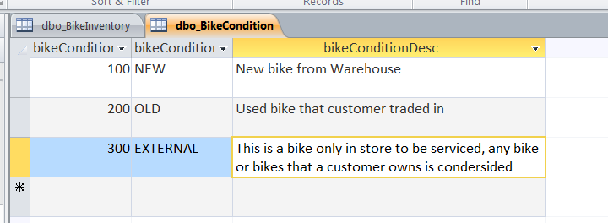
BikeInventory – Field containing data that describes each bike
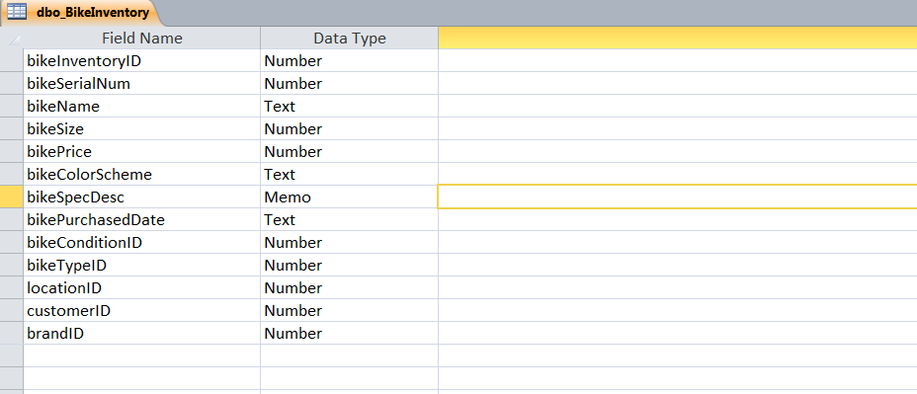
BikeInventoryService - list out all the service or work orders and their status. This is the bridge table between Service and BikeInventory.
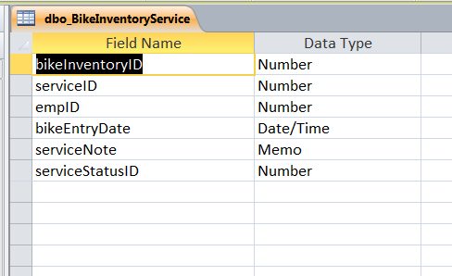
BikeType – describes the type of bike, IE Road Bike
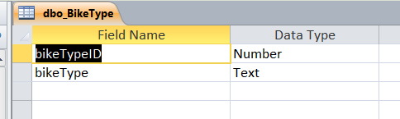
Brand- field for the brand of a particular bike
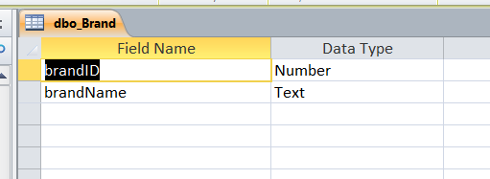

City – The table is populated with all cities in United States
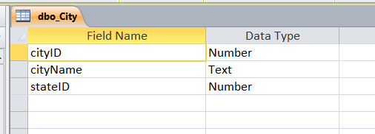
Customer- Contains data on each customer
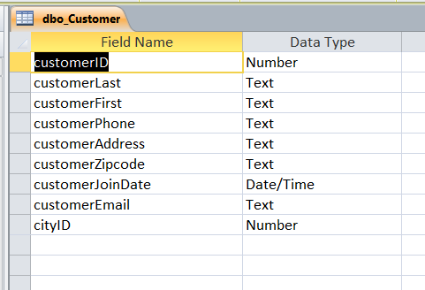

Employee- Contains data about each employee
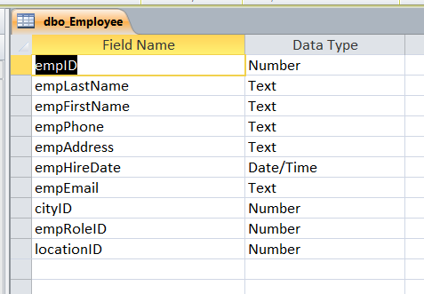
EmployeeRole- contains data on the roles assigned for each employee
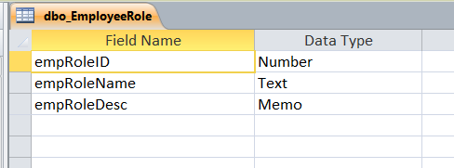

Event - data on events schedule by a bike shop
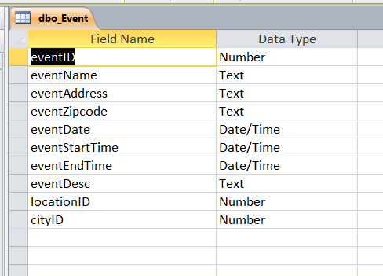
EventCustomer- tracks the attendance of the event. This is the bridge table for the Event and customer table
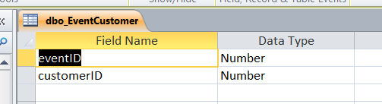
Location – Data for where each bike shop reside. This table also keeps the contact information for a particular bikeshop
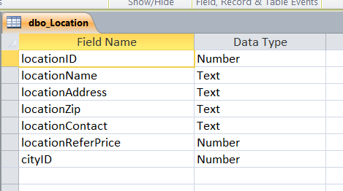
LocationService – the table allows the location to set prices for a particular service. This is a bridge table for Location and Service table.
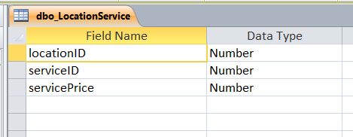
Reference- allow one bike shop to reference another.
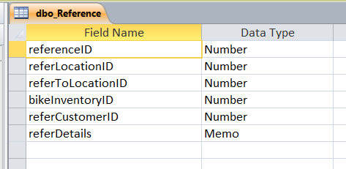
Service- name of the service provided by a bike shop.
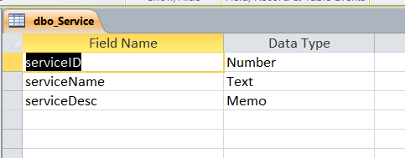

Service Status- the status of a particular service
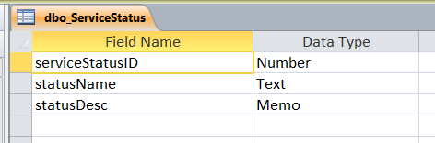
State – lists all the states in United States
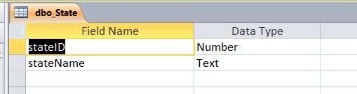
VBA Code to generate insert statements from MS Excel- The code below allow tables to be place in excel and when macro is activated inserts statements are generated for each row. The instert statements are written to an text file called instertStatement. The file is created within the same directory as the Excel spreatsheet. Short cut to activate is CTRL + I from the excel spreadsheet.
Option Compare Text
Sub instertStatement()

Dim myFile, tableName As Variant
Dim columnName, columnTotal, statement, statement2 As String
Dim wrkSheet As String
Dim exist As Boolean
Dim dataInsert As String
Dim I, k, j As Integer
''MsgBox ActiveWorkbook.Path

'Create and open new file
myFile = ActiveWorkbook.Path & "\insertsStatements.sql"
'the opened file is referred to as #1'
Open myFile For Append As #1

'Request input from the user for the Name of the Table
'The default tableName is tableName

tableName = InputBox("What is the table name?", , ActiveSheet.Name)
statement2 = "/* " + "INSERT Statements For: " + tableName + " */"

Print #1, statement2

wrkSheet = InputBox("Which Sheet to generate the insert Statements", , ActiveSheet.Name)

sheetChk wrkSheet

Sheets(wrkSheet).Activate

'columnTotal is the total number of columns that will
'have data insterted */

I = 1

Do While ActiveSheet.Cells(1, I).Value <> ""
I = I + 1
Loop

columnTotal = I - 1

'Collecting all column name and concatenating them
'in the form : column1, column2, column3, etc

If I = 1 Then
columnName = ActiveSheet.Cells(1, I).Value
Else
For I = 1 To columnTotal
If I = columnTotal Then
columnName = columnName + ActiveSheet.Cells(1, I).Value
Else
columnName = columnName + ActiveSheet.Cells(1, I).Value + ", "
End If
Next
End If

'Collect all rows, Insert Null where a row is blank
'Places single quotes around each object

k = 2: j = 2

Do While ActiveSheet.Cells(k, 1).Value <> ""
dataInsert = ""
For I = 1 To columnTotal
If I = columnTotal Then
If ActiveSheet.Cells(j, I).Text = "" Then
dataInsert = dataInsert + "NULL"
ElseIf IsNumeric(ActiveSheet.Cells(j, I).Value) = True Then
dataInsert = dataInsert + ActiveSheet.Cells(j, I).Text
Else
dataInsert = dataInsert + Chr(39) + ActiveSheet.Cells(j, I).Text + Chr(39)
End If
Else
If ActiveSheet.Cells(j, I).Text = "" Then
dataInsert = dataInsert + "NULL" + ", "
ElseIf IsNumeric(ActiveSheet.Cells(j, I).Value) = True Then
dataInsert = dataInsert + ActiveSheet.Cells(j, I).Text + ", "
Else
dataInsert = dataInsert + Chr(39) + ActiveSheet.Cells(j, I).Text + Chr(39) + ", "
End If
End If
Next

''MsgBox (dataInsert)

'Creates the insert Statement

statement = "INSERT INTO " + tableName + " (" + columnName + ")" + vbNewLine _
+ "Values" + " (" + dataInsert + ");"
' Append Statement to file #1

Print #1, statement
j = j + 1
k = k + 1

Loop

Close #1

End Sub

Sub sheetChk(ByVal sheetName As String)
Dim WS_Count As Integer
Dim I As Integer
Dim WorksheetExists As Boolean

' Set WS_Count equal to the number of worksheets in the active
' workbook.
WS_Count = ActiveWorkbook.Worksheets.Count

WorksheetExists = False
' Begin the loop.
For I = 1 To WS_Count

' Insert your code here.
' The following line shows how to reference a sheet within
' the loop by displaying the worksheet name in a dialog box.
'' MsgBox ActiveWorkbook.Worksheets(I).Name
If sheetName = ActiveWorkbook.Worksheets(I).Name Then
WorksheetExists = True
Exit Sub
End If

Next I

MsgBox ("The sheet you specified does not exists")
End
End Sub de used to Generate inserts VBA

